LCD Display Tutorial:

Goal:

Have the LCD Display display “ART TECH :D”

Components Needed:

Arduino

LCD1602 module

Potentiometer

Breadboard

Jumper Wires

Wiring:

K: GND

A: 5V

D7: pin12

D6: pin11

D5: pin10

D4: pin9

D3: N/A

D2: N/A

D1: N/A

D0: N/A

E: pin8

RW: GND

RS: pin7

VO: to potentiometer

VDD: 5V

VSS: GND

\*Wire potentiometer like normal, except the center wire connects to VO

Picture diagram:

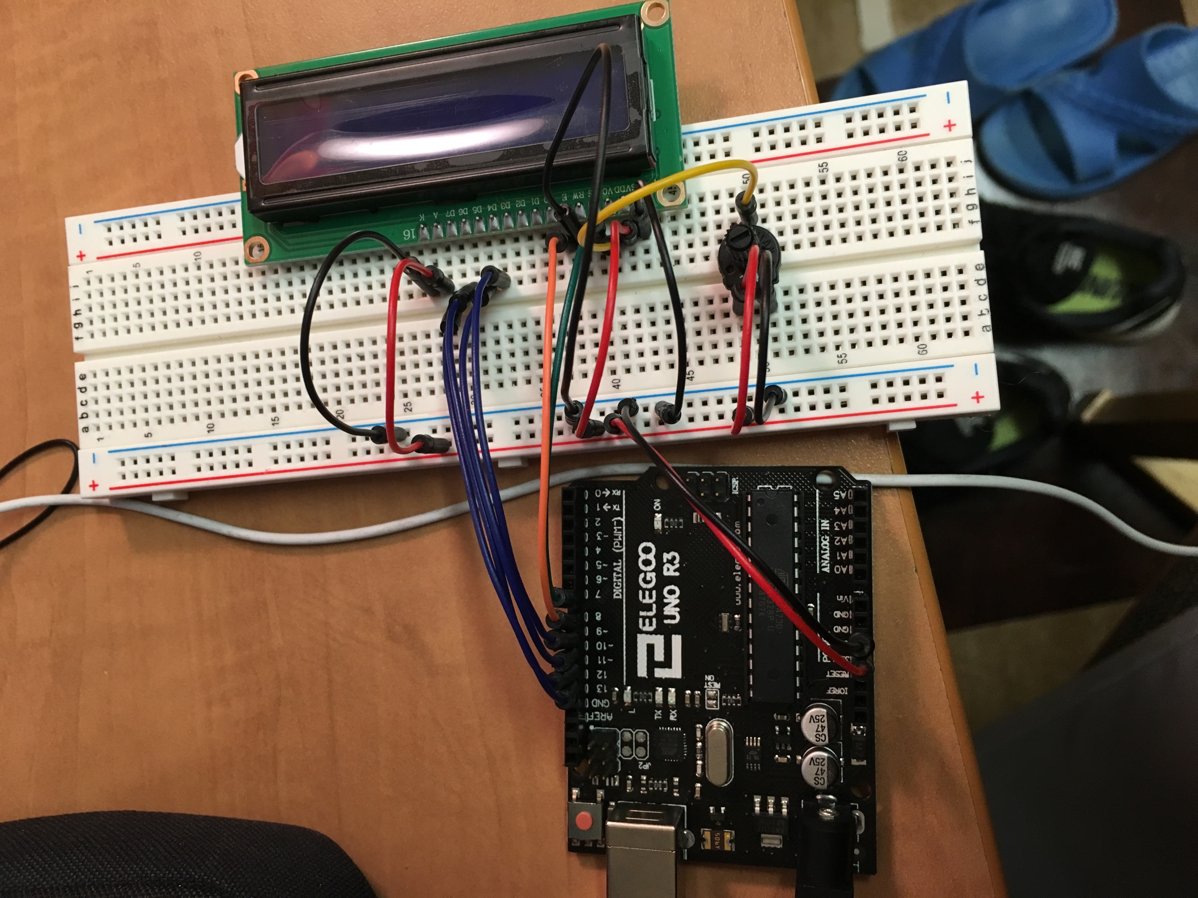

Code:

// (Go to library and pick “Liquid Crystal”)

#include <LiquidCrystal.h>

// (initialize with the numbers of the interface pins)

LiquidCrystal lcd(7, 8, 9, 10, 11, 12);

void setup() {

//( set up the LCD's number of columns and rows☺

lcd.begin(16, 2);

// Print a message to the LCD.

lcd.print("ART TECH :D");

}

void loop() {

// set the cursor to column 0, line 1

// (note: line 1 is the second row, since counting begins with 0):

lcd.setCursor(0, 1);

// print the number of seconds since reset:

lcd.print(millis() / 1000);

}

\*This code is largely from the Arduino example tutorial.

Result:

